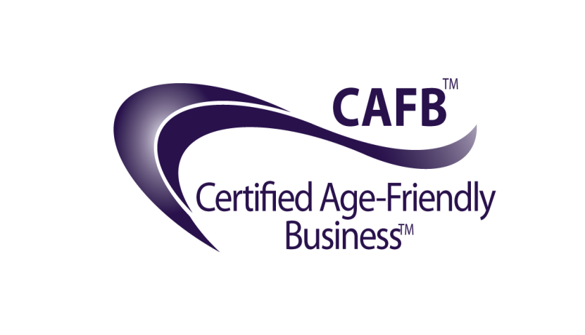
Certified Age-Friendly Business (CAFB)®
Code of Service

“We believe that people of all ages deserve a place in our communities and our businesses where they are welcome, acknowledged, safe and respected, and that when this happens, everybody wins.”

The Certified Age-Friendly Business® training program is an important component of the overall Age-Friendly Business® service revolution. Age-Friendly Business® was inspired by the United Nations endorsed Age-Friendly Cities initiative embraced throughout the world. It is our vision to expand the application of this noble undertaking, recognizing that businesses, professionals, and commercial interactions form an essential aspect of our maturing communities’ experience.

We believe that a history of age-discrimination and one-size fits all service can become a thing of the past, when those who have the will to make a difference embrace our Age-Friendly Business educational programs.

We believe that all levels of business and service have a role to play in the quality of inter-generational interaction within our communities.

Certified Age-Friendly Businesses® represent a variety of industries that:
- Are dedicated to service excellence;
- Are good community and corporate citizens;
- Have made the investment and commitment to better understand and serve the maturing population with skill, respect, and compassion.

This CAFB Code of Service identifies the fundamental principles that inform and direct the conduct of businesses, organizations and services holding a CAFB certification in good-standing.

Certified Age-Friendly Business (CAFB)®

Code of Service

- CAFBs ensure that all employees serving the 50+ population (in person or on the phone) have completed successfully the Age-Friendly Business® Foundation Course, and appreciate some of the unique needs and age-related changes facing their aging customers.

- CAFBs agree to be honest in all their communications and interactions, and to accurately reflect the benefits and features of their services and products.

- CAFBs endeavor to create an environment that is accessible, safe, and welcoming.

- CAFBs agree to treat the public, associates and co-workers courteously and with respect, regardless of their age, race, or socio-economic status.

- CAFBs come from a variety of industries, and many of these industries obligate the business to their specific code of conduct, health and safety regulations. CAFBs agree to uphold the requirements of their particular industry, and recognize that this CAFB Code of Service supports and supplements other relevant industry training requirements, codes and regulations.

- CAFBs agree to engage in fair competition.

- CAFBs agree to conduct themselves in a professional manner, refraining from profanity, or any other public behaviours that would be generally considered as inappropriate or offensive.

- CAFBs agree to operate within the spirit and intention of international, national, provincial, state, or territorial human rights codes.